Hands-On 1Task 1 needs to build base of project
Hands-On 1 Task 2 needs the below one’s
Header (Student Course Portal)
Navigation links (Home | Courses | Profile)
Welcome heading
Description
Statistics (Courses Available, Enrolled, GPA)
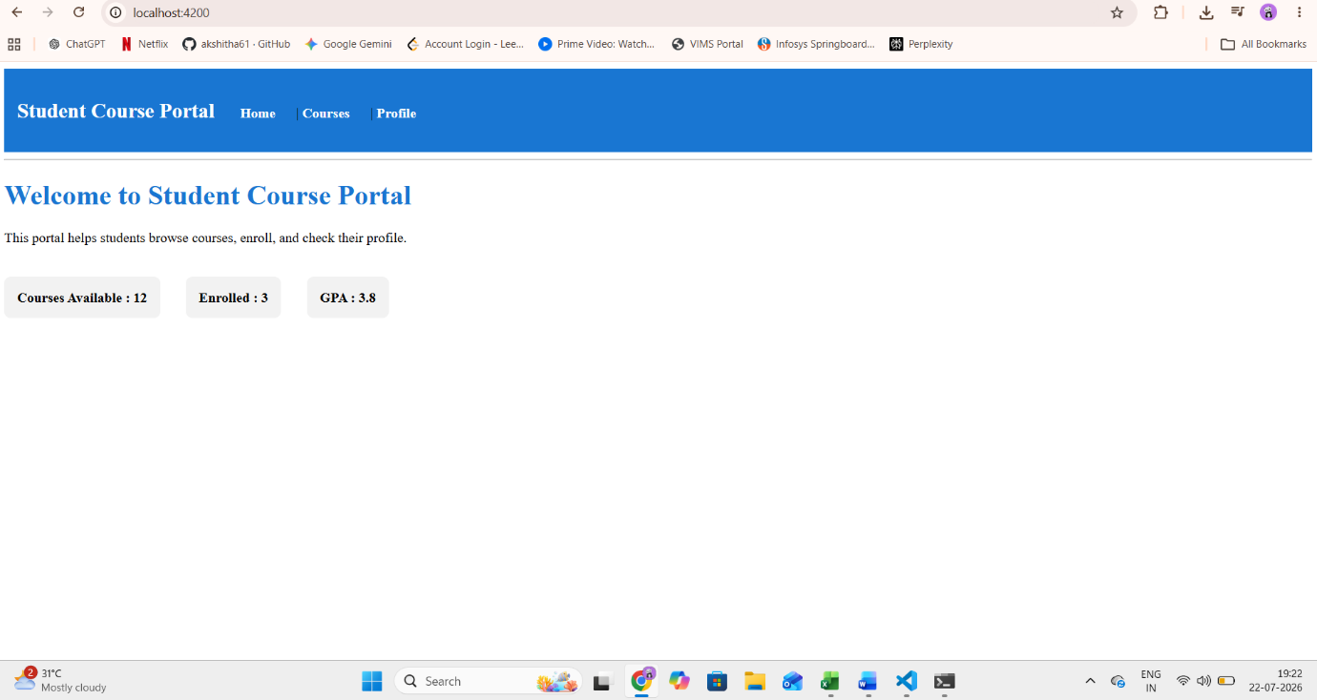
Hands-On 2 (Data Binding)
- Interpolation {{ }}
- Property Binding [disabled]
- Event Binding (click)
- Two-Way Binding [(ngModel)]
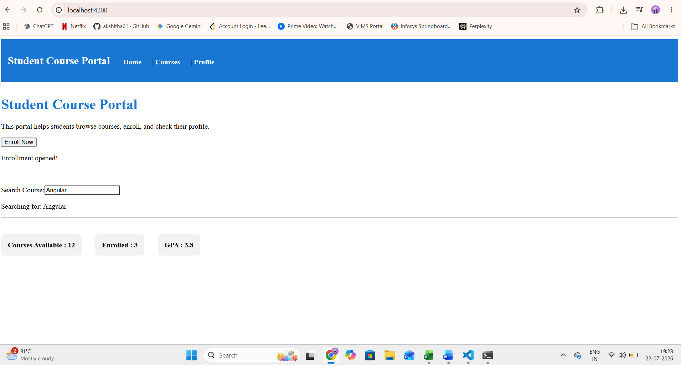
Hands-On 2 - Task 2: Lifecycle Hooks.
- ngOnInit
- ngOnDestroy
- ngOnChanges (using a new component)
- 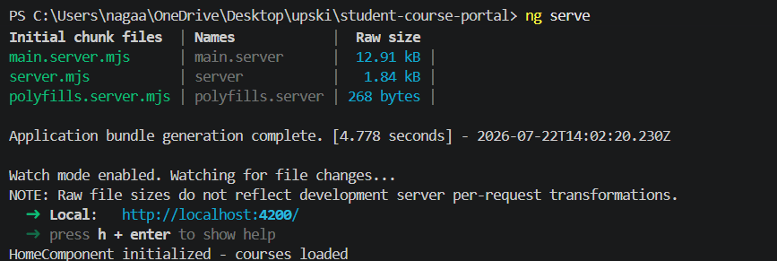
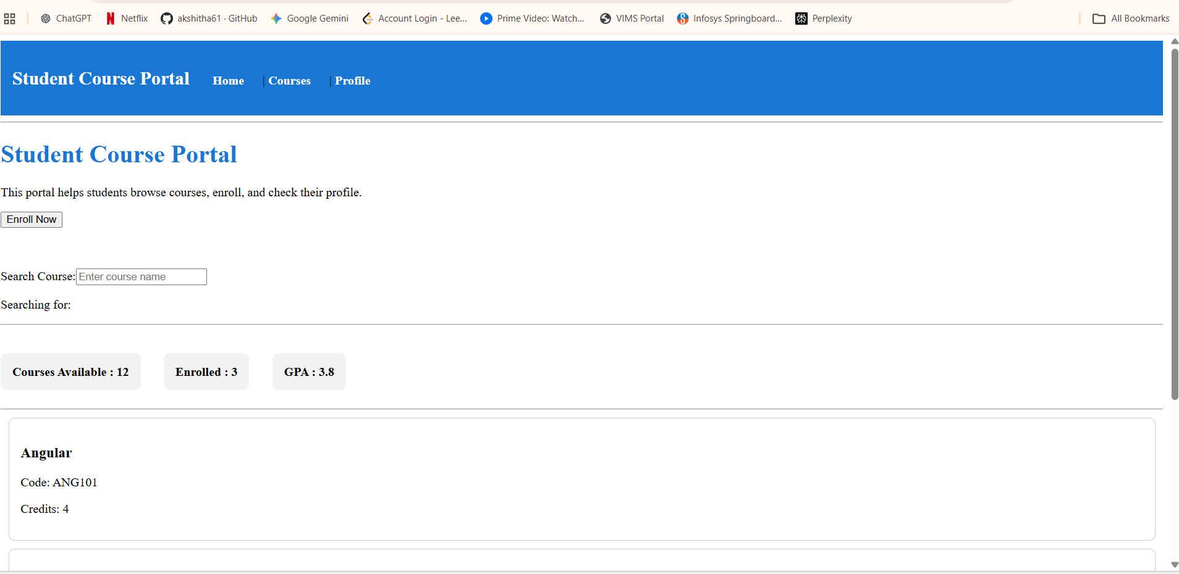
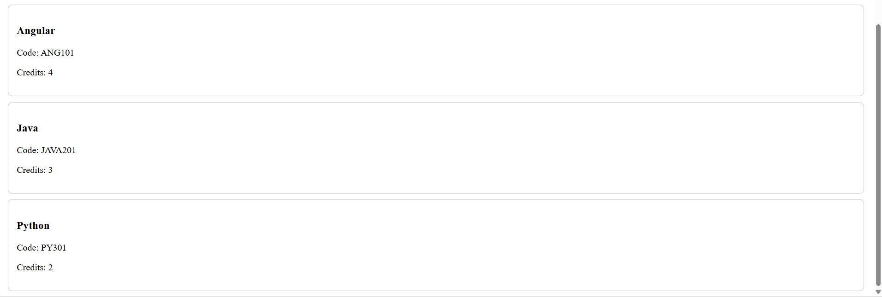
Hands-On 2 – Task 3: Parent-Child Communication using @Input and @Output
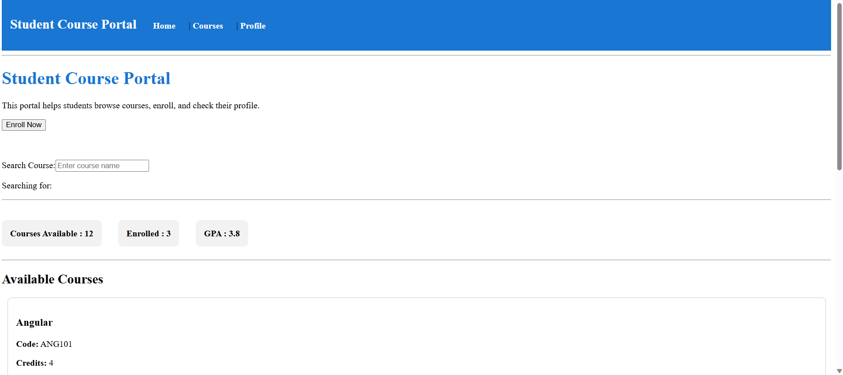
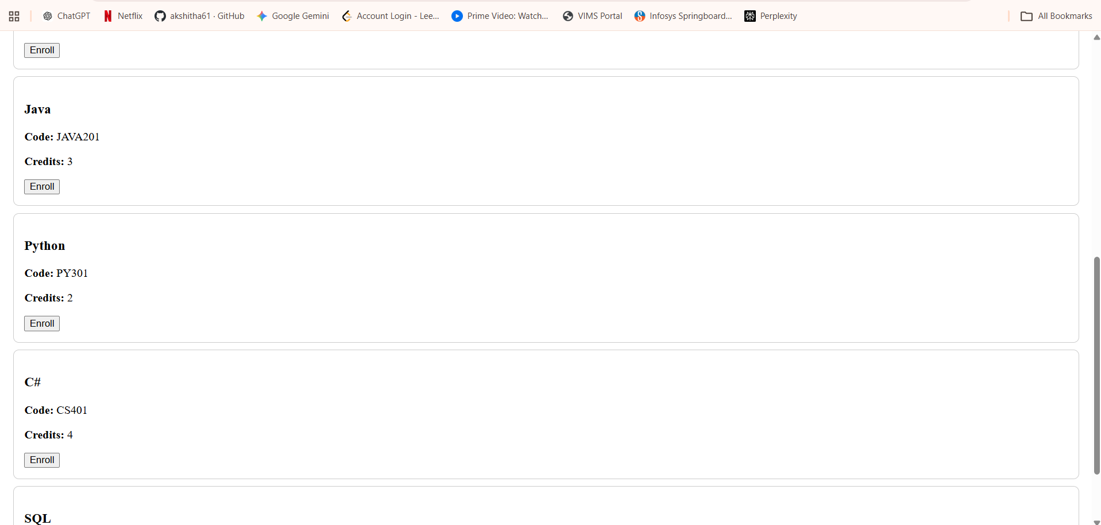
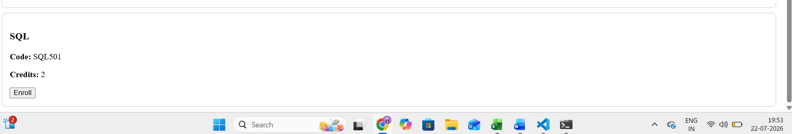
Hands-On 3 – Task 1: Structural Directives (*ngIf, *ngFor, *ngSwitch)
By the end of this task:
- Show "Loading courses..." for 1.5 seconds.
- Display the course list after loading.
- Use trackBy with *ngFor.
- Show a Passed, Failed, or Pending badge using *ngSwitch.
- Show "No courses available." if the course list is empty.
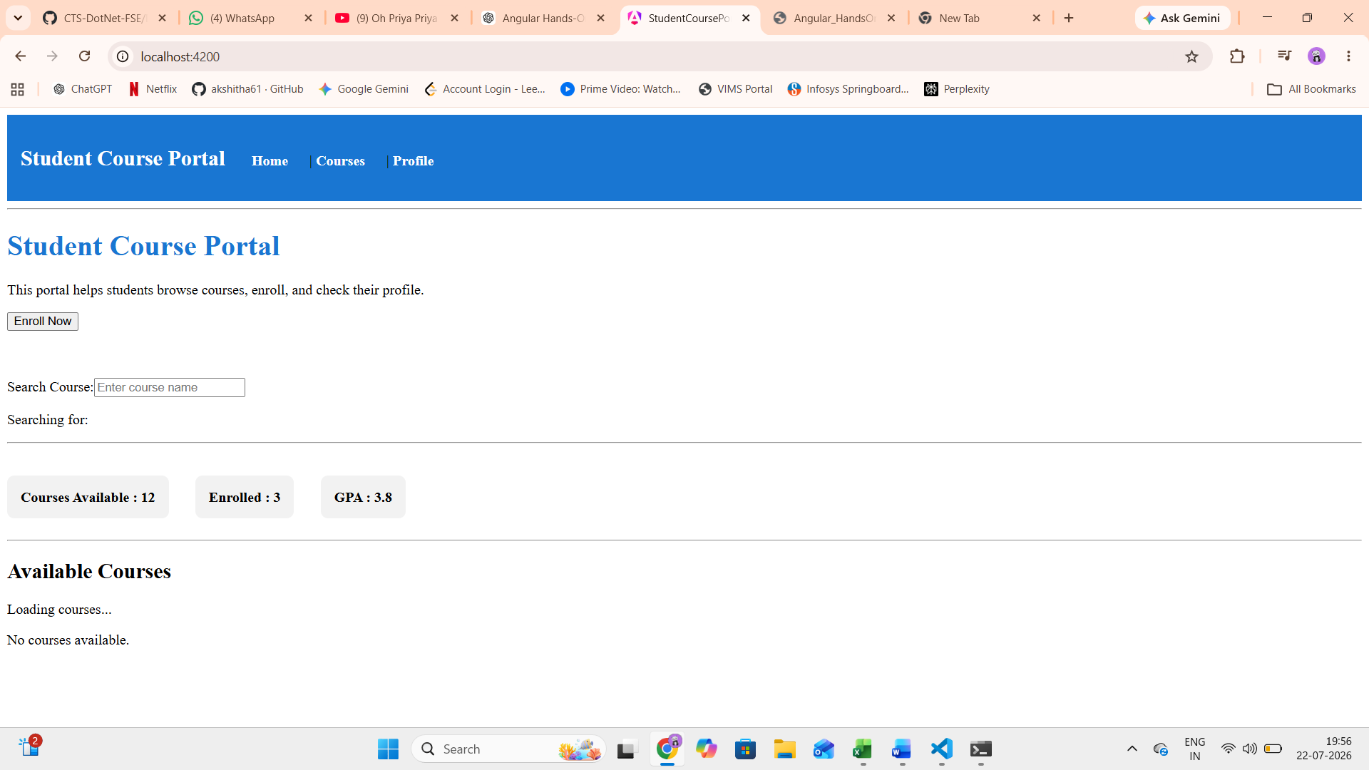
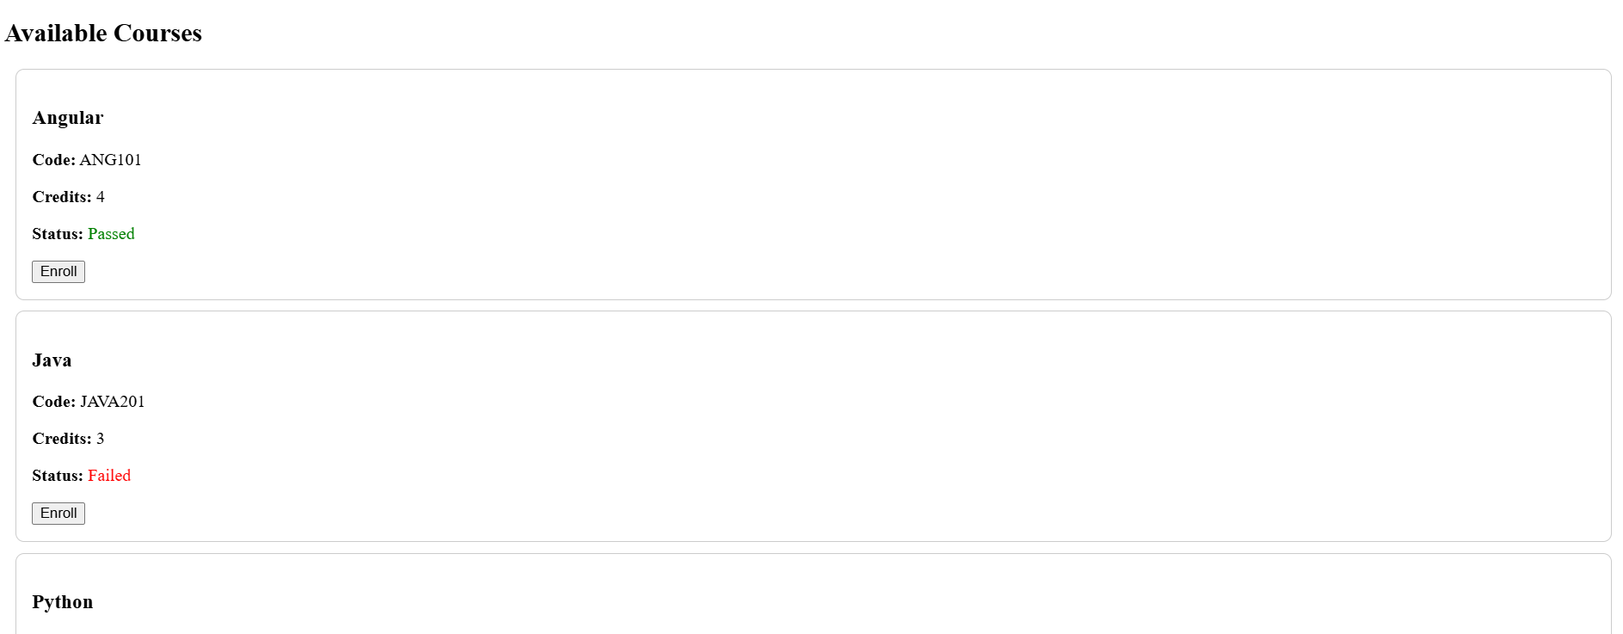
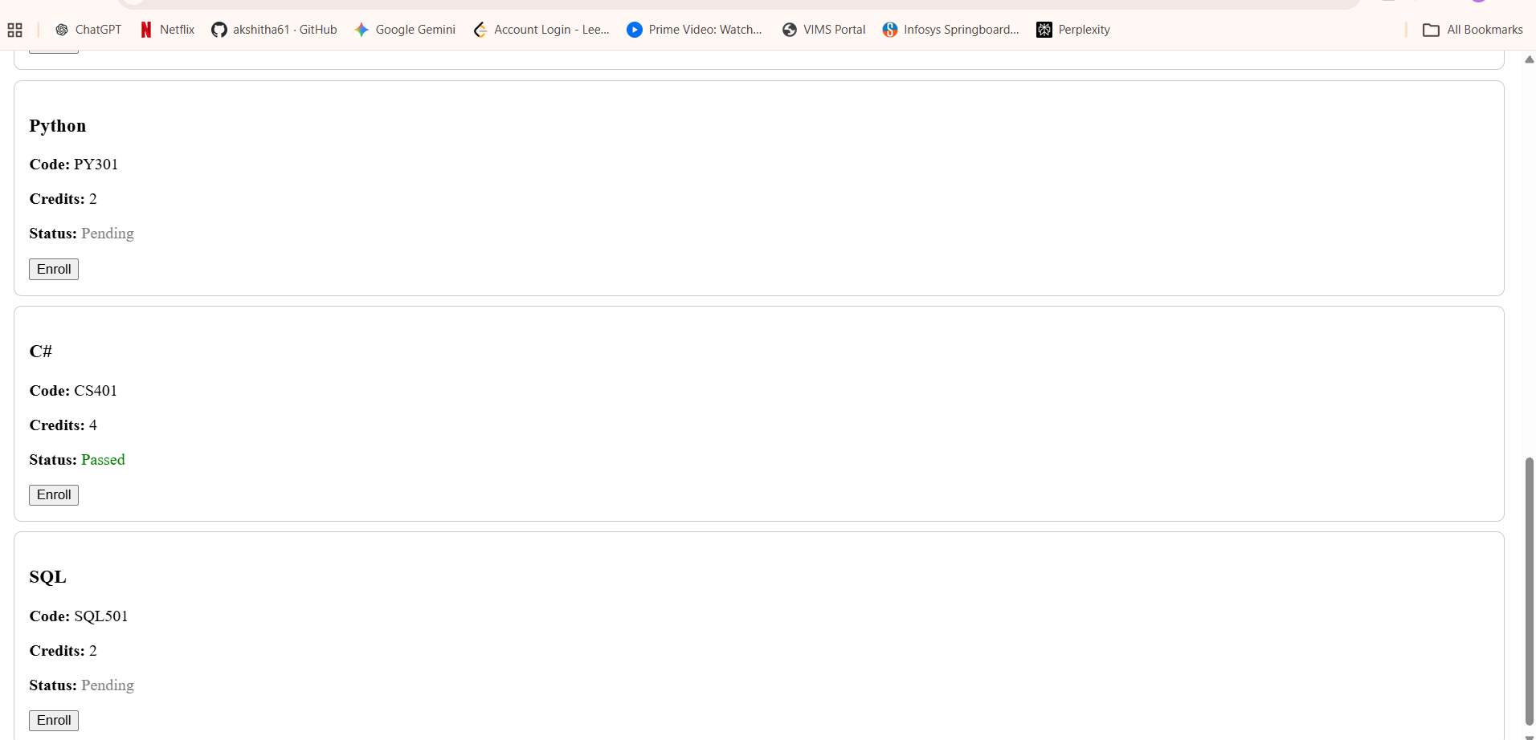
Hands-On 3 – Task 2: ngClass and ngStyle
card--enrolled class when a course is enrolled.
card--full class when credits ≥ 4.
Dynamic left border color using ngStyle.
"Show Details" button that expands the card using ngClass.
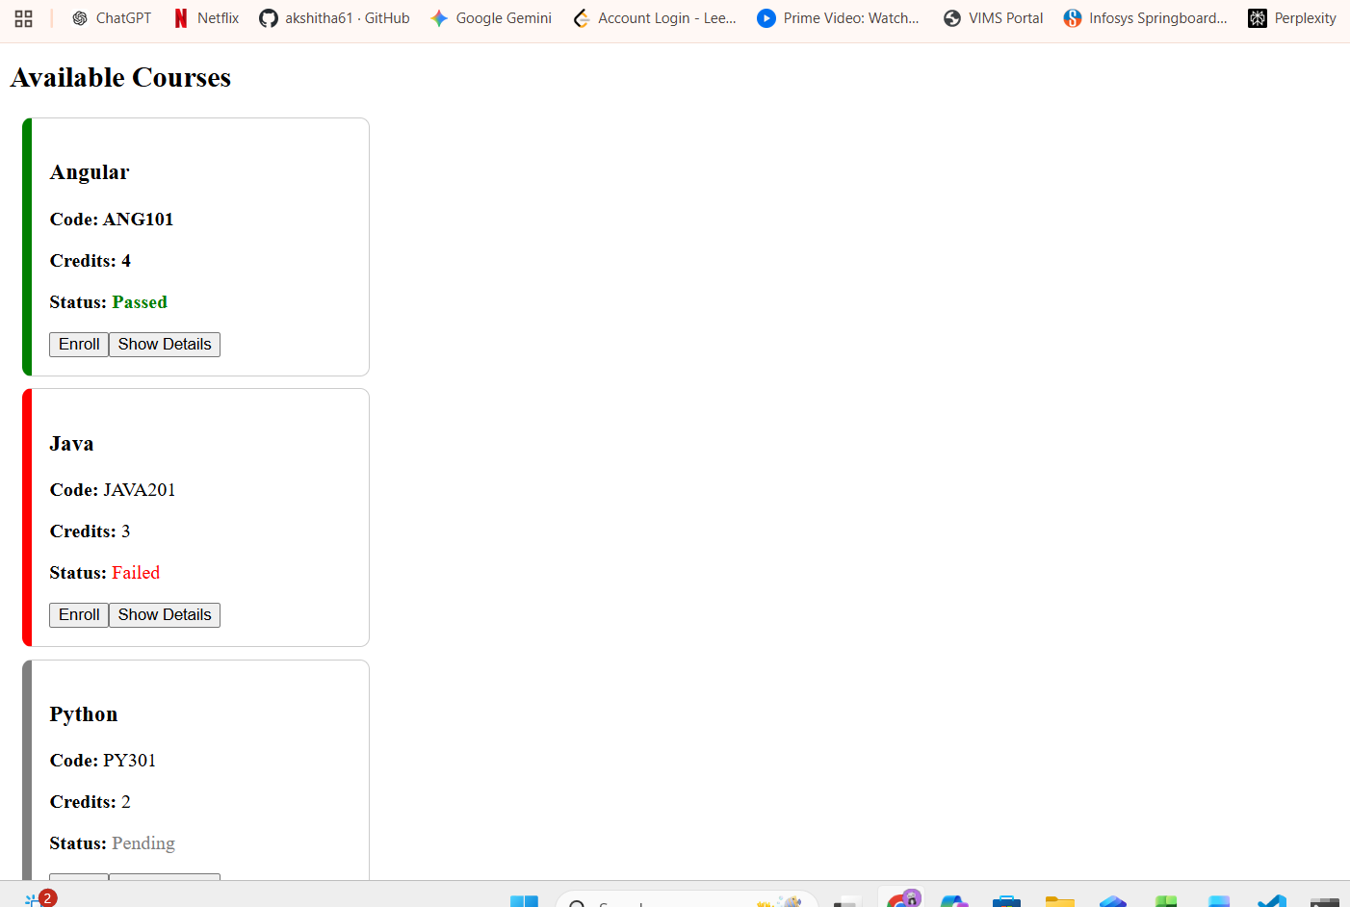
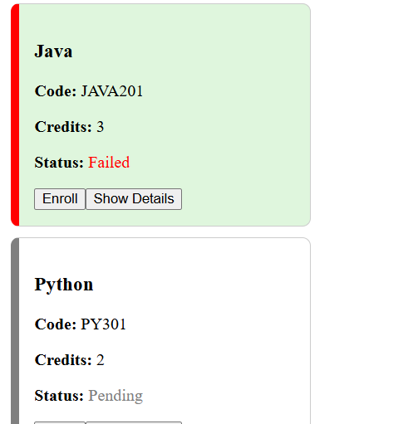
Hands-On 3 – Task 3:
- Create a custom directive (appHighlight) to highlight a course card on hover.
- Create a custom pipe (creditLabel) to display values like:
  - 1 Credit
  - 3 Credits
  - No Credits
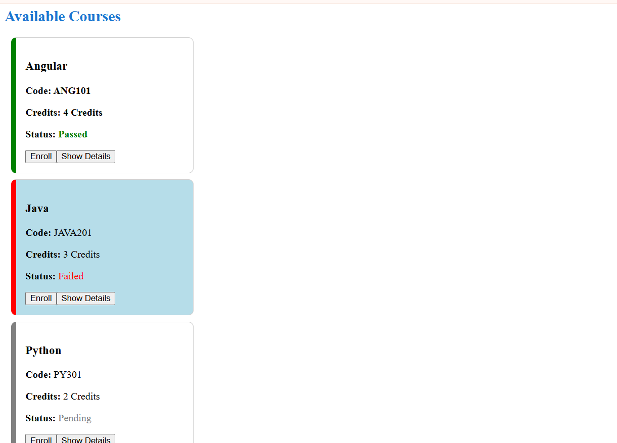

Hands-On 4 – Template-Driven Forms & Validation
The form will contain:
- Student Name
- Student Email
- Course ID
- Preferred Semester
- Agree to Terms (checkbox)
- Submit button
- Reset button
- Validation messages
- Success message
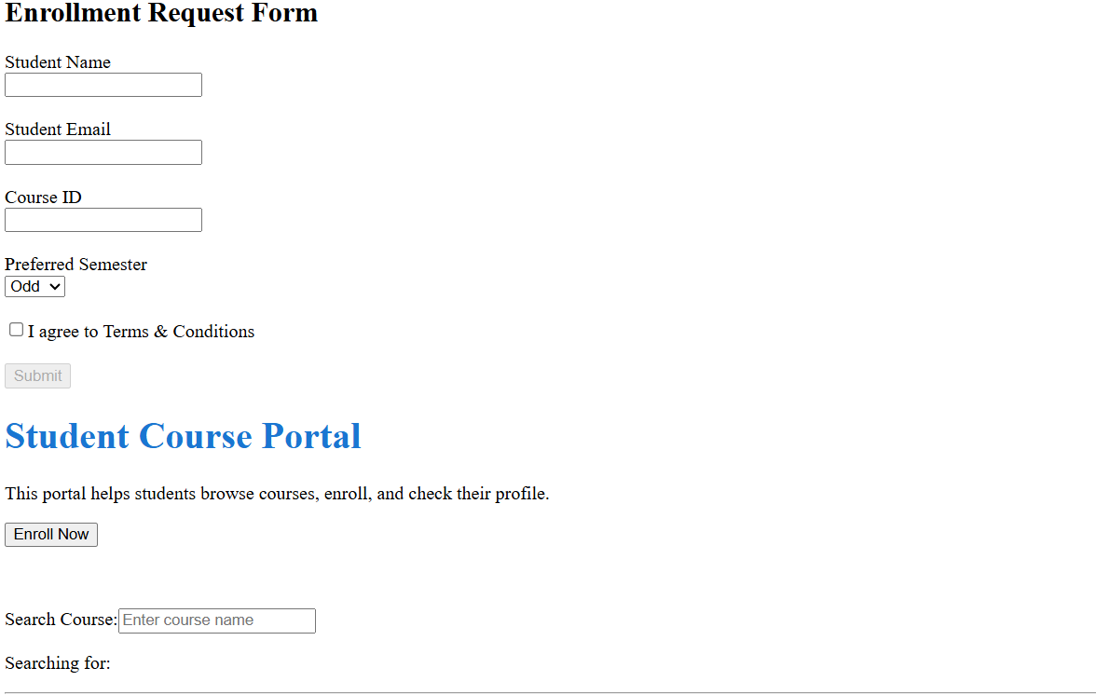
Hands-On 4 – Task 2: Validation and Error Messages. This task adds validation, error messages, success notification, and reset functionality to the enrollment form.
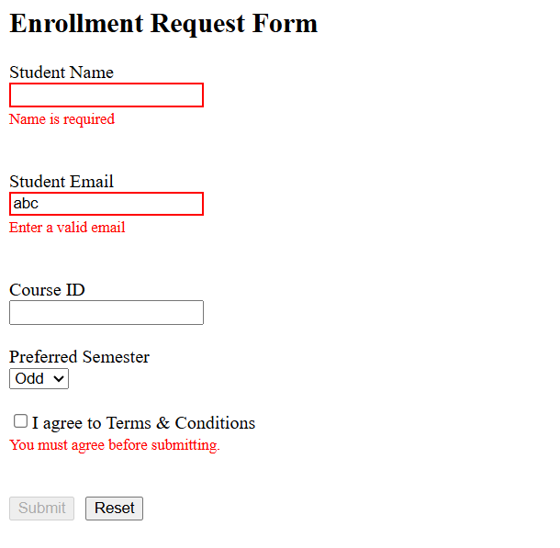
Hands-On 5: Reactive Forms – FormBuilder, FormGroup & Validators
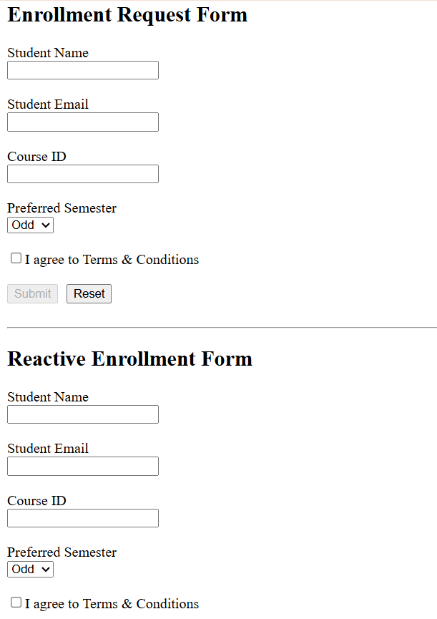
Hands-On 5 – Task 2
Custom Validator
Async Validator
FormArray (multiple additional courses)
Add/Remove Course buttons
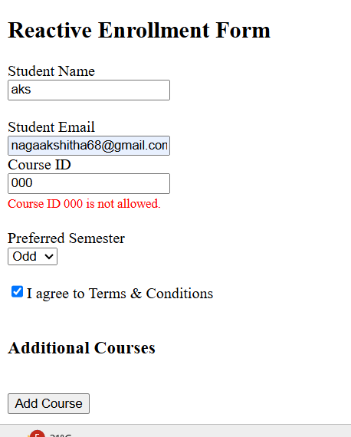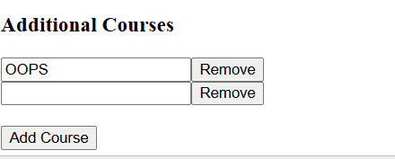
Hands-On 6: Angular Services & Dependency Injection, where you'll create a service to manage course data instead of storing it directly in the component.
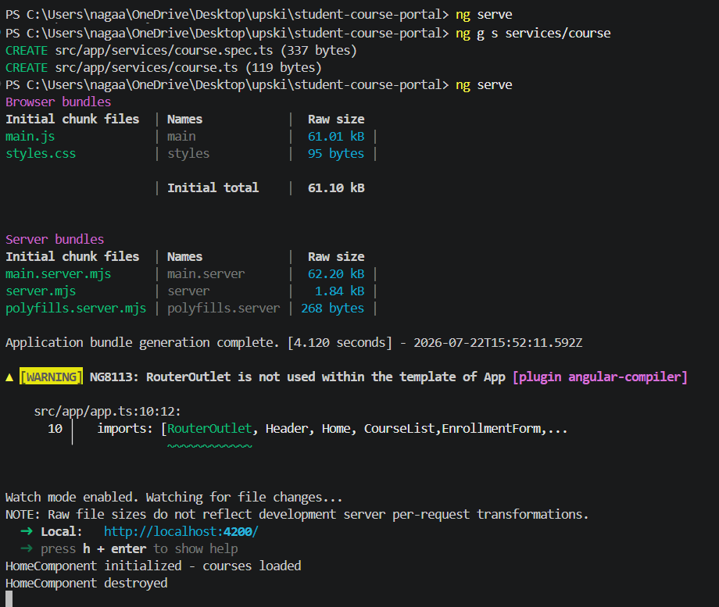
Hands-On 6 – Task 2: Add, Update, and Delete Courses using the Service.
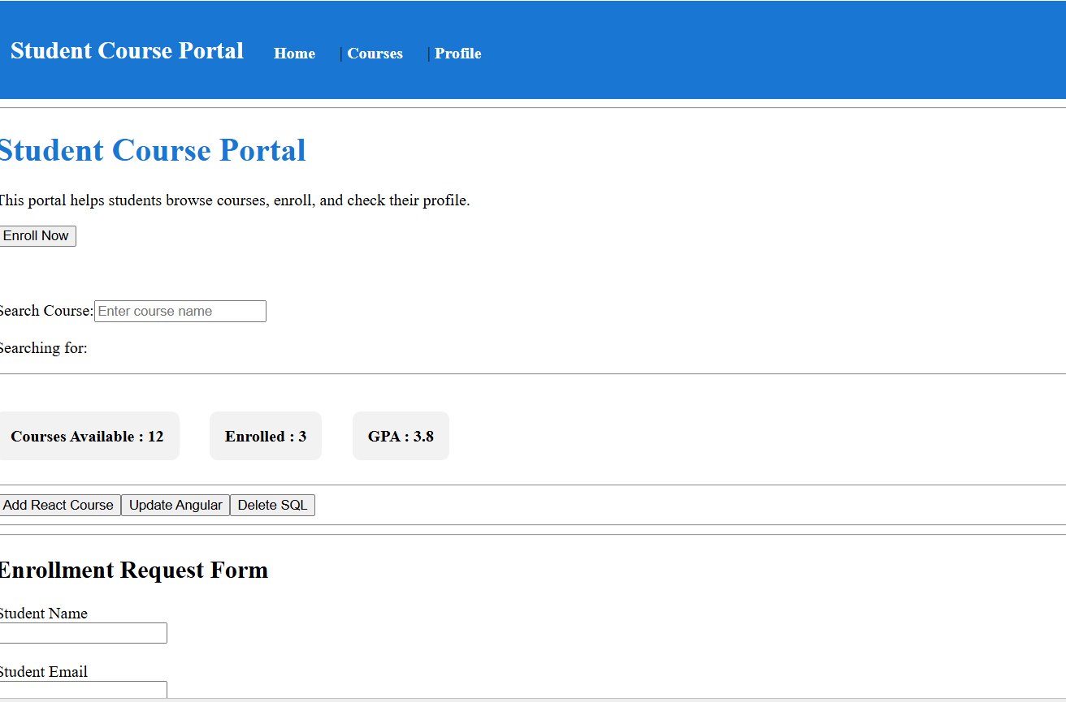
Hands-On 7 – HTTP Client & REST API.
how to retrieve data from a REST API using Angular's HttpClient
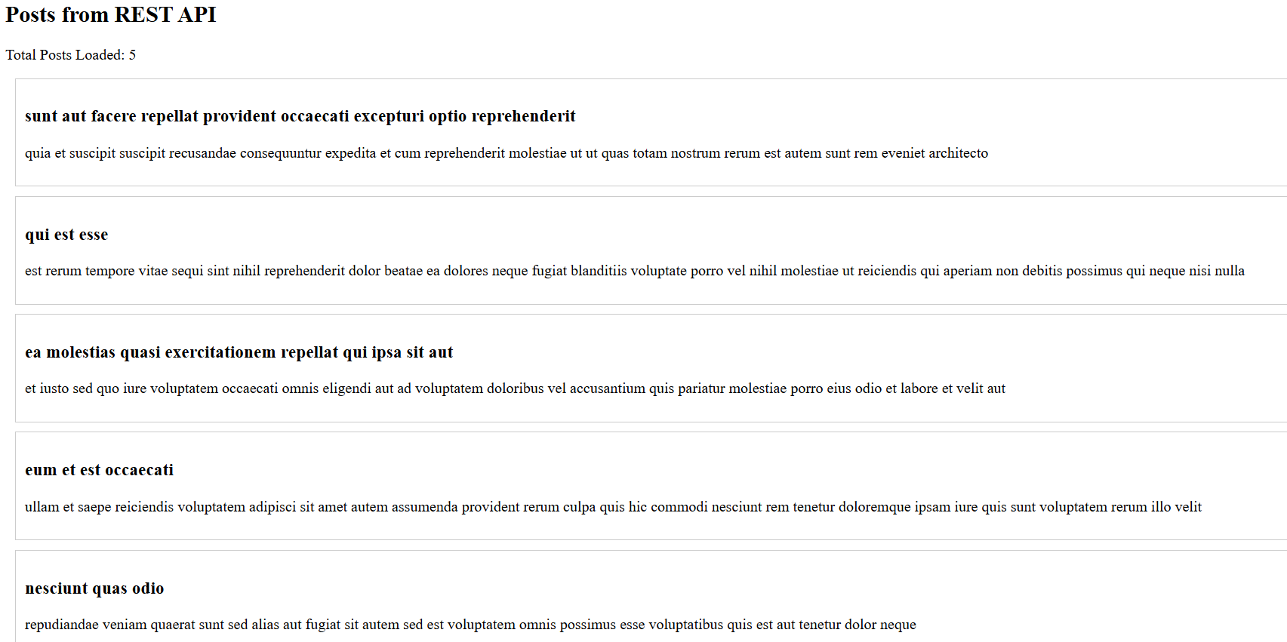
Hands-On 7 – Task 2 (POST Request)
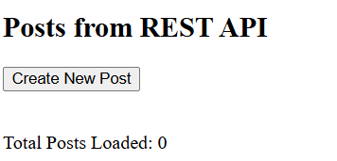
Hands-On 7: PUT (Update) and DELETE requests.
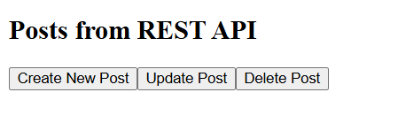
Angular Routing & Navigation
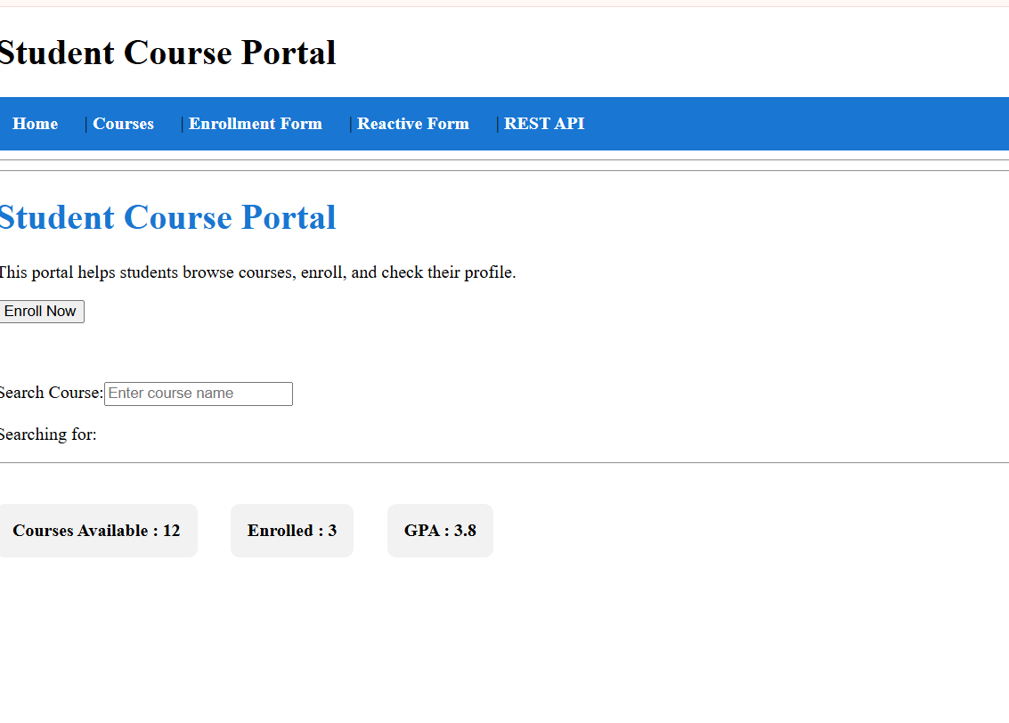
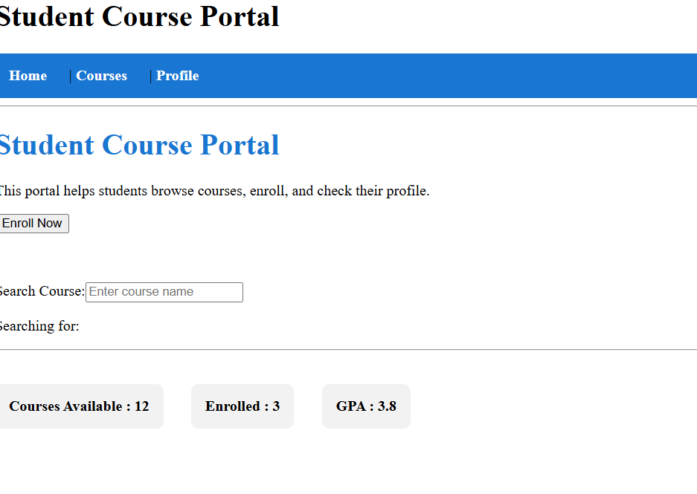
Hands-On 7 – Task 2: Route Parameters

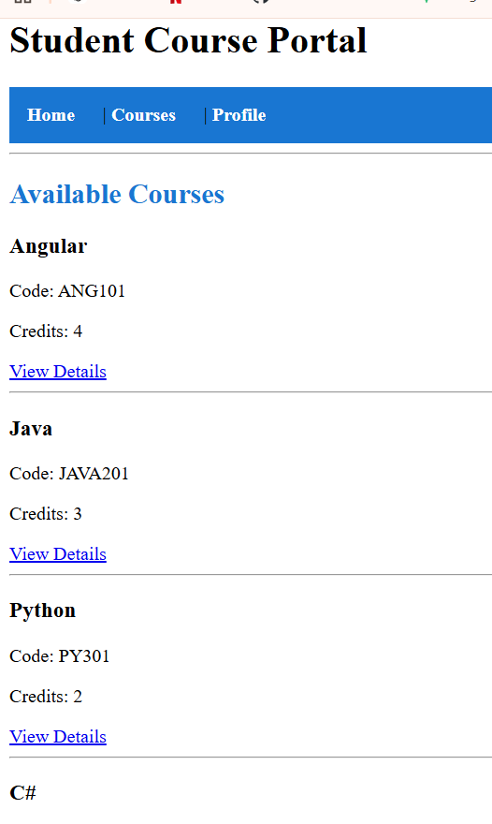
Hands-On 7 – Task 3: Programmatic Navigation using Router
Instead of clicking a link, we'll navigate to the Course Detail page when the user clicks a button.
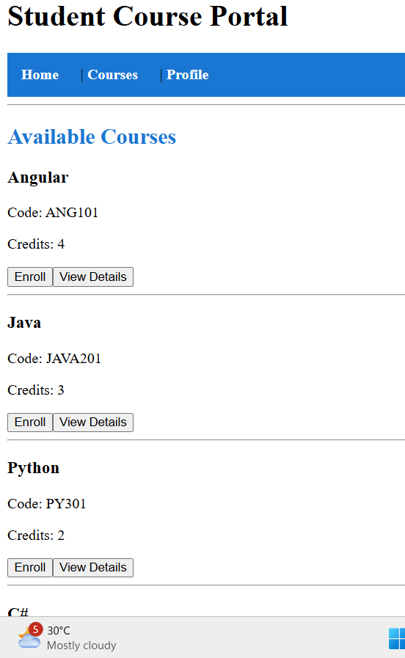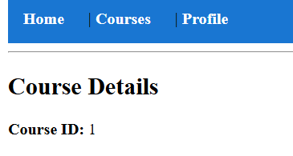
CourseDetailComponent.
The goal is to read the :id route parameter using ActivatedRoute and load the corresponding course from CourseService
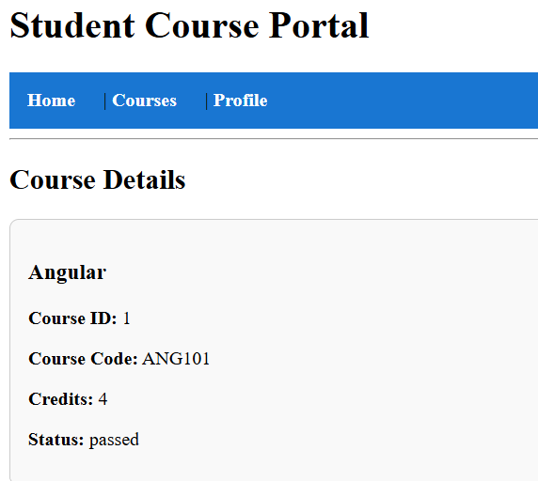
Query Parameters
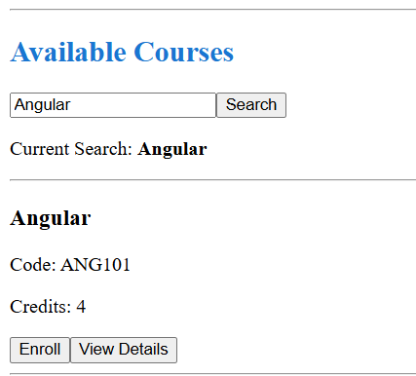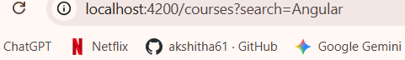
Hands-On 7 – Task 4: Wildcard Route (404 Page)
The goal is to display a Not Found page whenever the user enters an invalid URL.

